**PUSL3190 Computing Individual Project**

**Project Proposal**

**Online Fraud Detection in Financial Transactions**

Supervisor: Ms. Hirushi Dilpriya

Name: Athurugirige M Amasha

Plymouth Index Number: 10899282

Degree Program: BSc (Hons) in Data Science

**Chapter 01: Problem Statement**

The increasing digitalization of financial services, from e-commerce platforms to mobile banking, has transformed the way consumers and businesses interact with their financial transactions. While this shift offers remarkable convenience and accessibility, it has also led to the rise of online fraud, one of the most prominent challenges faced by financial institutions, businesses, and consumers.

Online financial fraud can take various forms such as identity theft, unauthorized credit card usage, phishing, and account takeovers. As fraudsters develop increasingly sophisticated methods, traditional rule-based fraud detection systems have struggled to keep pace. These systems often rely on predefined rules, flagging transactions that exceed certain thresholds or deviate from expected behaviors. While they can detect straightforward cases of fraud, they fall short when it comes to more complex, evolving fraud tactics.

One of the primary issues with current fraud detection systems is their high rate of false positives and false negatives. False positives cause inconvenience to legitimate customers, resulting in a poor user experience, while false negatives mean fraudulent activities go undetected, leading to financial losses and damaged trust. Moreover, the sheer volume of real-time transactions complicates matters, as fraud detection systems need to act fast to prevent unauthorized activities before, they cause significant harm.

The challenges are compounded by the highly imbalanced nature of fraud detection datasets, where the majority of transactions are legitimate, making it difficult for traditional machines to detect fraud accurately. This problem is critical because fraud is a rare but high-impact event that requires careful handling of class imbalance.

This project seeks to address these challenges by developing and comparing machine learning models Random Forest and Gradient Boosting in both Python and R. The aim is to first identify the best-performing model in Python, replicate the same in R, and then compare the two implementations. The final objective is to select the most accurate and efficient model for detecting fraud in real-time online financial transactions.



***Current fraud detection systems face several critical challenges:***

1. Platform-Specific Performance Variations
   * Implementation differences between Python's scikit-learn and R's randomForest package led to varying performance metrics
   * Memory management and processing speed differences affect real-time detection capabilities
   * Platform-specific optimization techniques impact model efficiency
   * Integration capabilities with existing systems vary significantly between platforms
2. Resource Utilization Challenges
   * Different memory footprints between Python and R implementations
   * Varying computational resource requirements during model training
   * Platform-specific limitations in handling large-scale datasets
   * Different approaches to parallel processing and optimization
3. Implementation Complexity
   * Divergent approaches to feature engineering and preprocessing
   * Different default hyperparameter settings affecting model performance
   * Varying levels of community support and available resources
   * Platform-specific debugging and optimization tools
4. Deployment and Integration Issues
   * Different approaches to model serialization and deployment
   * Varying levels of compatibility with web frameworks
   * Platform-specific challenges in maintaining model performance in production
   * Different requirements for scaling and load balancing
5. Maintenance and Updating Challenges
   * Platform-specific requirements for model updates and retraining
   * Different approaches to version control and model governance
   * Varying levels of backward compatibility
   * Platform-specific requirements for documentation and knowledge transfer

***These challenges are further complicated by the unique characteristics of fraud detection data:***

1. Data Imbalance
   * Fraudulent transactions typically represent less than 0.1% of total transactions
   * Platform-specific approaches to handling imbalanced datasets
   * Different sampling and weighting techniques available on each platform
2. Real-Time Processing Requirements
   * Need for sub-second prediction times
   * Different approaches to optimization and caching
   * Varying capabilities in handling streaming data
   * Platform-specific limitations in processing speed
3. Feature Engineering Complexity
   * Different approaches to handling temporal features
   * Varying capabilities in processing categorical variables
   * Platform-specific limitations in handling missing data
   * Different methods for feature selection and importance ranking

The financial impact of these challenges is significant:

* False positives lead to customer friction and operational costs
* False negatives result in direct financial losses
* Inefficient resource utilization increases operational expenses
* Integration challenges lead to implementation delays and cost overruns

This project addresses these challenges by conducting a comprehensive comparison of Random Forest implementations in Python and R, focusing on:

* Performance metrics and accuracy
* Resource utilization and efficiency
* Deployment capabilities and integration
* Maintenance requirements and scalability
* Real-world application in fraud detection

**Chapter 02: Project Description**

***Project Overview***

The goal of this project is to design and implement an advanced fraud detection system that can effectively distinguish between legitimate and fraudulent online transactions. This system will utilize machine learning techniques specifically **Random Forest** and **Gradient Boosting** models chosen for their robustness and ability to handle complex classification tasks. Given the rapid growth of online transactions, this project will aim to create a solution that is not only accurate but also efficient enough to process transactions in real-time.

The project will involve a comparative analysis of Python and R implementations of these models, enabling a cross-platform evaluation of performance, efficiency, and ease of use in fraud detection contexts. The best-performing model will ultimately be integrated into a **web application** for real-time fraud detection, simulating deployment in an operational environment.

***Project Objectives and Explanations***

Objective 1: Data Collection and Preprocessing

A comprehensive dataset of online financial transactions will be acquired, ideally covering a diverse range of transactions, both legitimate and fraudulent. The dataset will include features that reflect patterns relevant to fraud detection, such as:

* **Transaction amount**: Unusually high amounts can be a fraud indicator.
* **Device type**: Different devices (e.g., mobile, desktop) may correlate with fraud likelihood.
* **Time of transaction**: Transactions during unusual hours might indicate suspicious activity.
* **Geographical location**: Discrepancies between billing and transaction locations can signal fraud.
* **Payment method**: Certain payment methods may be more vulnerable to fraud.

This dataset will undergo **data cleaning** and **preprocessing** steps to ensure it is ready for model training. Missing data will be handled carefully by imputing values where necessary or removing records if imputation is infeasible. **Feature engineering** will be applied to derive additional meaningful features (e.g., transaction frequency per user) that can enhance model performance.

To address the class imbalance a common challenge in fraud detection this project will employ **Synthetic Minority Over-sampling Technique (SMOTE)**, which generates synthetic examples in the minority class (fraud). While SMOTE can improve model performance on imbalanced datasets, there is a risk of **overfitting**, where the model may learn patterns specific to oversampled data. Therefore, other techniques, such as **class weighting** or **under sampling**, may also be considered and evaluated.

Objective 2: Model Development in Python (Random Forest and Gradient Boosting)

In the initial development phase, **Python** will be used to implement and train **Random Forest** model due to Python's extensive machine learning libraries, such as **scikit-learn** for Random Forest and **XGBoost** for Gradient Boosting. Python’s flexibility and the advanced optimization options available within these libraries make it ideal for an iterative and customizable approach to model training.

1. **Random Forest**: A Random Forest model is particularly suited for this task as it handles high-dimensional data well and provides robust predictions by aggregating results from multiple decision trees. This model also gives insights into feature importance, helping identify the most critical indicators of fraud.
2. **Gradient Boosting**: Gradient Boosting, specifically XGBoost, is known for its high accuracy in classification tasks. By sequentially training on residual errors from previous iterations, Gradient Boosting can capture complex patterns in the data, making it an ideal choice for fraud detection, where subtle differences in patterns can signal fraud.

The models will be evaluated using metrics such as **accuracy**, **precision**, **recall**, and **F1-score** to determine their effectiveness. Since fraud detection demands high precision and recall, these metrics will help evaluate the models' performance on both detecting frauds accurately (precision) and minimizing missed fraudulent transactions (recall).

Objective 3: Model Replication in R

Once the best-performing model is identified in Python, the same model will be replicated in **R** using equivalent libraries **randomForest** for Random Forest and **xgboost** for Gradient Boosting. This objective is designed to assess the differences in implementation, performance, and resource utilization between the two languages, which is valuable for cross-platform evaluations.

1. **Implementation and Challenges**: Due to slight differences in how Python and R libraries handle model parameters and optimizations, careful attention will be given to matching hyperparameters and preprocessing steps between both implementations.
2. **Performance Comparison**: The performance of the R models will be evaluated using the same metrics as the Python models, ensuring a fair comparison. Additionally, **processing speed** and **memory usage** will be monitored, as these can vary based on the underlying language and libraries used.

Objective 4: Model Comparison (R vs. Python)

This project seeks to provide a detailed comparison between the Python and R implementations to identify which environment offers better performance, ease of use, and efficiency for fraud detection. Both environments have unique advantages; for example, Python is often preferred for machine learning due to its extensive libraries and community support, while R is popular in statistical analysis and offers efficient handling of data transformations.

1. **Accuracy and Performance Metrics**: By using the same dataset and metrics across both implementations, the accuracy, precision, recall, and F1-score will be compared directly.
2. **Resource Utilization and Processing Speed**: Given the demand for real-time fraud detection, both memory usage and processing speed are critical. Metrics such as **time to train** and **time to predict** will be recorded to assess each language’s suitability for real-time applications.
3. **User Experience**: Factors such as ease of coding, availability of debugging tools, and compatibility with deployment environments (e.g., web frameworks) will be noted. This can influence the feasibility of each platform for future projects.

Objective 5: Web Application Development

After selecting the best-performing model, it will be deployed within a real-time **web application**. This application will be built using **Python’s Flask or Django frameworks**, chosen for their simplicity, flexibility, and ease of integration with machine learning models.

The web app will allow users to:

* **Input transaction data**: Users or automated systems can input data for new transactions.
* **Receive fraud predictions instantly**: The web will deliver a fraud/no-fraud prediction within seconds, simulating a real-world use case.

To minimize latency and ensure efficient processing, caching techniques may be employed, and API endpoints will be optimized to handle multiple requests simultaneously. Security measures, such as input validation and data encryption, will be included to ensure safe handling of sensitive financial data.

Objective 6: Testing and Optimization

The final phase will involve **extensive testing** of the web application under different load conditions to ensure it can handle multiple requests efficiently without compromising accuracy or speed. Several techniques will be applied for optimization, including:

* **Model Pruning**: For Random Forests, reducing the depth or number of trees may improve speed.
* **Hyperparameter Optimization**: Fine-tuning parameters like learning rate, depth, and estimators will further enhance model performance.
* **Performance Monitoring**: Latency and throughput will be regularly monitored to identify any performance bottlenecks.

Testing will also include checks for false positives and false negatives to fine-tune the model's thresholds, improving overall user experience and reliability in real-time environments. Finally, documentation will be prepared, detailing each phase of the project and including a user manual for the web application.

***Project Keywords***

1. Fraud Detection
2. Machine Learning
3. Random Forest
4. Gradient Boosting
5. Real-Time Processing



**Chapter 03: Research Gap**

***Literature Review***

The rapid expansion of digital transactions has led to a surge in financial fraud cases, posing severe risks to financial institutions, businesses, and consumers. Machine learning (ML) has emerged as a key technology for fraud detection, offering capabilities to detect patterns in data and differentiate between legitimate and fraudulent transactions. However, fraud detection in this domain presents unique challenges, such as handling class imbalance, enabling real-time detection, and comparing ML models across platforms. This literature review synthesizes recent research findings on these challenges and identifies gaps that this project aims to address.

***1. Challenges in Fraud Detection: Class Imbalance***

One of the most significant challenges in fraud detection is the **class imbalance** in transaction datasets, where fraudulent transactions constitute only a small fraction of the total data. This imbalance often leads ML models to focus on predicting the majority class (legitimate transactions), resulting in high **false-negative rates** that allow actual fraud cases to go undetected. Research indicates that techniques like **SMOTE (Synthetic Minority Over-sampling Technique)** can be effective in addressing this imbalance by generating synthetic samples for the minority class, enhancing model performance at rare events. However, SMOTE may also lead to **overfitting** if the model learns synthetic patterns too specifically, thereby limiting generalization to new data.

**Advanced Hybrid Resampling Techniques**: A study incorporating **SMOTE-Tomek resampling** a combination of SMOTE with Tomek links showed that the hybrid technique improves robustness by removing noisy samples and minimizing overfitting, resulting in a more accurate and generalizable model (Research Abstract 1). This approach helps maintain a balance between detecting fraud and minimizing false positives and negatives.

Additionally, certain ML models, such as **Random Forest** and **Gradient Boosting**, are more resilient to imbalanced data. Random Forest builds multiple decision trees on different subsets of the data, making it less likely to skew toward the majority class, while Gradient Boosting improves iteratively on errors, enabling it to capture subtle fraud patterns effectively. This project will employ these models along with hybrid resampling techniques to address the class imbalance, ensuring accurate detection of both fraud and legitimate transactions.

**Research Gap**: While studies have applied SMOTE and hybrid techniques like SMOTE-Tomek, there is limited research exploring the combined application of these methods with ensemble models such as Random Forest and Gradient Boosting specifically for fraud detection. This project aims to fill this gap by using hybrid techniques with robust ensemble models to improve the detection of rare fraud cases without overfitting.

***2. Real-Time Fraud Detection and the Need for Low Latency***

As the volume of digital transactions grows, financial institutions require systems that can identify fraudulent activities in **real-time** to prevent unauthorized access and financial losses. Traditional rule-based systems rely on batch processing, identifying fraud only after it has occurred, which is insufficient for real-time applications. Machine learning models offer a solution by providing faster, pattern-based fraud detection. However, real-time detection also demands models that can process large volumes of data with minimal latency, which many complex ML algorithms struggle to achieve.

**Low-Latency, High-Throughput Models**: Research highlights the effectiveness of **Random Forest** and **XGBoost** in real-time detection due to their high accuracy and low latency. XGBoost is optimized for computational efficiency and supports parallel processing, making it suitable for high-throughput environments requiring rapid predictions (Research Abstract 4). Meanwhile, **continuous learning** capabilities are essential for adapting to new fraud patterns, as fraudulent methods evolve over time. Techniques such as **Relational Graph Convolutional Networks (R-GCN)**, which capture dynamic relationships within transaction data, offer promising future applications in real-time fraud detection

**Research Gap**: Although the need for real-time fraud detection has been identified, there is limited research on optimizing ensemble models like Random Forest and XGBoost for real-time applications in live, high-volume financial environments. This project addresses this gap by designing a real-time fraud detection system optimized for speed and accuracy, utilizing Random Forest and Gradient Boosting models. Continuous learning methods will be explored to allow the system to adapt to evolving fraud tactics.

***3. Cross-Platform Comparison: Python vs. R for Fraud Detection***

Despite the widespread use of **Python** and **R** in machine learning, few studies directly compare their performance for practical fraud detection applications. Python is widely favored for machine learning due to its flexibility and comprehensive libraries (e.g., **scikit-learn**, **XGBoost**), while R excels in statistical analysis with packages like **randomForest** and **xgboost**. Each platform has its advantages: Python’s ecosystem supports rapid model development and deployment, whereas R provides a robust environment for statistical analysis and data visualization.

**Differences in Processing Efficiency**: Research comparing Python and R in financial machine learning applications has found that Python often outperforms R in high-volume, low-latency applications, due to better support for iterative development and integration with deployment systems (Research Abstract 4). However, R’s capabilities in handling complex statistical modeling make it valuable for detailed exploration data analysis and feature engineering.

**Research Gap**: There is limited research directly comparing the performance of Random Forest and Gradient Boosting implementations across Python and R for fraud detection. This project addresses this gap by implementing and testing both models on the same fraud detection dataset in Python and R, providing insights into platform-specific advantages in terms of **accuracy, processing speed, and memory efficiency**.

***4. Advances in Machine Learning Techniques for Fraud Detection***

Research has introduced various ML models and techniques that have significantly advanced fraud detection. Models such as **XGBoost**, **Artificial Neural Networks (ANNs)**, and **Support Vector Machines (SVMs)** have been widely adopted in financial fraud detection. For example, a study comparing XGBoost, ANN, and **Relational Graph Convolutional Networks (R-GCN)** found that XGBoost achieved an accuracy of 97%, while R-GCN reached 98.5% (Research Abstract 2). R-GCN, which captures complex interdependencies between transactions through graph-based structures, is particularly well-suited for datasets with interconnected transaction data, providing highly accurate fraud predictions.

**Hybrid Modeling Approaches**: Hybrid models, which combine algorithms to enhance performance on imbalanced datasets, have also shown promise. A study using SVM and Logistic Regression with a class-balancing approach demonstrated that hybrid models can reduce false negatives and improve AUC scores, resulting in more reliable fraud detection (Research Abstract 3). This approach illustrates that combining algorithms can create a more nuanced and accurate model that effectively distinguishes fraudulent from legitimate transactions.

**Research Gap**: Although advanced models like XGBoost and hybrid techniques have shown effectiveness in fraud detection, few studies focus on integrating these methods with hybrid class-balancing approaches specifically tuned for financial fraud. This project seeks to address this gap by implementing Random Forest and Gradient Boosting models with hybrid resampling techniques, enabling robust fraud detection for imbalanced datasets.

***Summary***

This literature review highlights the advancements and limitations in machine learning-based fraud detection, specifically in addressing class imbalance, enabling real-time detection, and comparing platform performance. The key research gaps identified are:

1. **Class Imbalance**: Limited research on the combined application of hybrid resampling techniques (e.g., SMOTE-Tomek) with ensemble models like Random Forest and Gradient Boosting for fraud detection. This project fills this gap by employing these techniques to improve accuracy without overfitting.
2. **Real-Time Detection**: Limited optimization of ensemble models such as Random Forest and XGBoost for real-time applications in high-throughput environments. This project addresses this by designing a low-latency fraud detection system optimized for real-time use.
3. **Cross-Platform Comparison**: Few direct comparisons of machine learning models for fraud detection across Python and R. This project bridges this gap by comparing Random Forest and Gradient Boosting implementations in both platforms on the same dataset, evaluating accuracy, efficiency, and scalability.

By addressing these research gaps, this project aims to develop a robust fraud detection system capable of handling real-world data challenges, providing insights into model and platform selection that can guide future applications in financial fraud detection.

**Chapter 04: Requirements Analysis**

***Software Requirements***

* Python: Python programming language with libraries such as scikit-learn, XGBoost, and Flask/Django for model development and web application deployment.
* R: R programming language with libraries like randomForest and xgboost for model development and evaluation.
* Jupyter Notebook: For experimenting with models during development in Python.
* RStudio: For model development and experimentation in R.

***Hardware Requirements***

* Minimum 8 GB RAM and multi-core CPU to handle large datasets.
* A GPU (optional) for faster training of complex models during optimization.

***Knowledge Requirements***

* Proficiency in machine learning, particularly with Random Forest and Gradient Boosting models.
* Expertise in both Python and R programming for model development and evaluation.
* Knowledge of web development for deploying the best-performing model into a real-time system.

***Data Collection***

Data collection is a critical part of developing an effective fraud detection system. This project will use a synthetic dataset of online financial transactions, containing 10,000 records with detailed information on transaction characteristics. Key features in the dataset will include:

* Transaction Amount: Numeric value indicating the transaction amount.
* Transaction Time: Hour of the day when the transaction occurred.
* Device Type: Type of device used (e.g., mobile, desktop, tablet).
* Geographical Location: Region where the transaction originated.
* Payment Method: Payment type used (e.g., credit card, debit card).
* Is International: Boolean indicating whether the transaction was cross-border.
* Transaction Type: Type of transaction (e.g., purchase, transfer).
* IsFraud: Target variable, set to 5% of the total transactions to represent fraudulent activity.

The IsFraud variable, with a 5% fraud rate, is higher than typical real-world rates (usually between 0.1% and 1%). This approach has advantages for model training, allowing the models to learn fraud patterns more effectively without heavy class imbalance techniques like SMOTE (Synthetic Minority Over-sampling Technique). However, additional testing on datasets with a lower fraud rate will be performed later to evaluate the model’s real-world robustness.

***Data Analysis***

Data analysis will involve examining patterns within the dataset to guide model development. Specific steps include:

* Exploratory Data Analysis (EDA): EDA will involve identifying trends, distributions, and anomalies within the data. Visualization techniques (e.g., histograms, box plots) and statistical summaries will be used to understand feature behavior.
* Feature Selection: Identifying the most relevant features for fraud detection is essential for effective modeling. Techniques like correlation analysis and feature importance from initial models will help pinpoint key indicators of fraud.
* Class Imbalance Assessment: The project will start with a 5% fraud rate for initial training, which is higher than real-world rates to facilitate model training and comparative analysis between Python and R implementations. In later stages, additional analysis with a dataset closer to real-world fraud rates (0.5%–1%) will help evaluate the model’s ability to generalize under highly imbalanced conditions.

***System Design***

System design involves planning the architecture and functional requirements for the fraud detection system. The core components are:

* Data Pipeline: Responsible for preprocessing incoming transaction data, handling missing values, encoding categorical variables, and normalizing numerical features.
* Modeling Layer: The modeling layer will consist of Random Forest and Gradient Boosting models, initially developed in Python and later replicated in R. Both models will be optimized for accuracy and speed, with specific attention to handling the 5% fraud rate.
* API/Integration Layer: The model will be deployed in a real-time web application using Flask or Django. This layer will handle transaction requests, process data through the model, and return fraud predictions.
* User Interface: A simple, intuitive interface allowing users to enter transaction data and receive fraud predictions instantly. This UI will prioritize ease of use and responsiveness.
* Security and Logging: Security protocols will protect transaction data, while logging will enable tracking of predictions, model performance, and data anomalies.

***System Development***

System development encompasses the coding and implementation phases, where each component of the system is built and integrated. Key tasks include:

* Preprocessing Pipeline: Scripts will be developed for data cleaning, handling missing values, encoding categorical features, and normalizing numerical data. Techniques like SMOTE and class weighting will be implemented if lower fraud rates are simulated later.
* Model Training in Python: Initial models (Random Forest and Gradient Boosting) will be developed and optimized in Python, using libraries like scikit-learn and XGBoost. The 5% fraud rate will facilitate training, while later testing with lower fraud rates will require additional adjustments for handling class imbalance.
* Model Replication in R: The chosen model will be replicated in R with randomForest and xgboost libraries, ensuring consistent preprocessing steps and parameter settings to maintain comparability with the Python model.
* Web Application Development: A Flask or Django-based application will serve as the web interface, providing an API that accepts transaction data and returns fraud predictions. Development will focus on ensuring low-latency predictions for near-real-time detection.
* Documentation: Each component will be documented, including setup instructions, code functionality, and design explanations.

***Testing/Evaluation***

Testing and evaluation will confirm that the system meets performance standards and provides reliable fraud detection. Evaluation criteria include:

* Model Evaluation: Metrics such as accuracy, precision, recall, and F1-score will measure the model’s performance. Given the 5% fraud rate, precision and recall will be prioritized to assess the system’s ability to detect fraud accurately without excessive false positives.
* Cross-Platform Comparison: Testing on both Python and R implementations will involve measuring accuracy, processing speed, and memory efficiency. Using the same dataset (initially at a 5% fraud rate) will ensure fair comparisons. Additional testing on a dataset with a lower fraud rate (e.g., 1%) will simulate real-world conditions, allowing analysis of each platform’s performance under significant class imbalance.
* Web Application Testing: The web application will undergo end-to-end testing for:
  + Latency testing to ensure rapid response times.
  + Load testing to evaluate the application’s performance under high transaction volumes.
  + Security testing to verify secure data handling and user authentication measures.
* User Acceptance Testing (UAT): Real or simulated users will assess the web app for usability and prediction accuracy, offering feedback for potential enhancements.
* Model Optimization: Based on testing results, model tuning and optimization will be performed. Techniques like model pruning and hyperparameter tuning will be applied to balance processing speed and accuracy, especially as the model is tested on lower fraud rates.

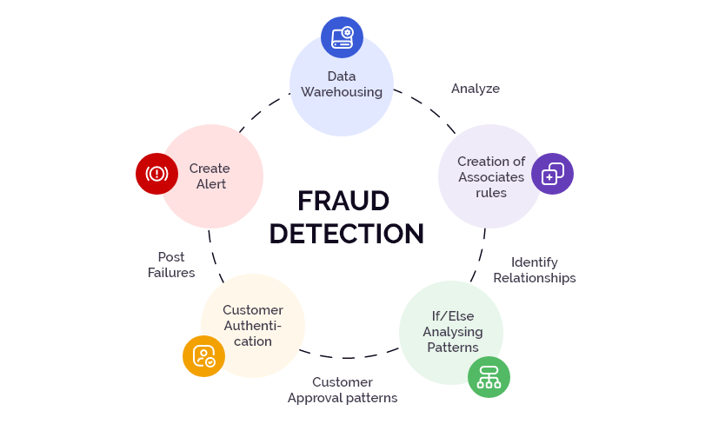

**Chapter 05: Timeline**

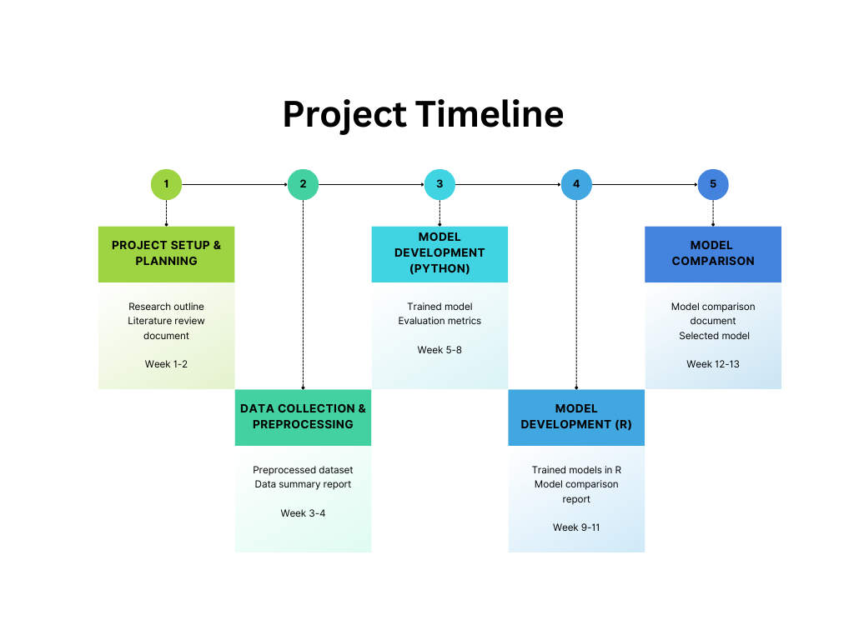

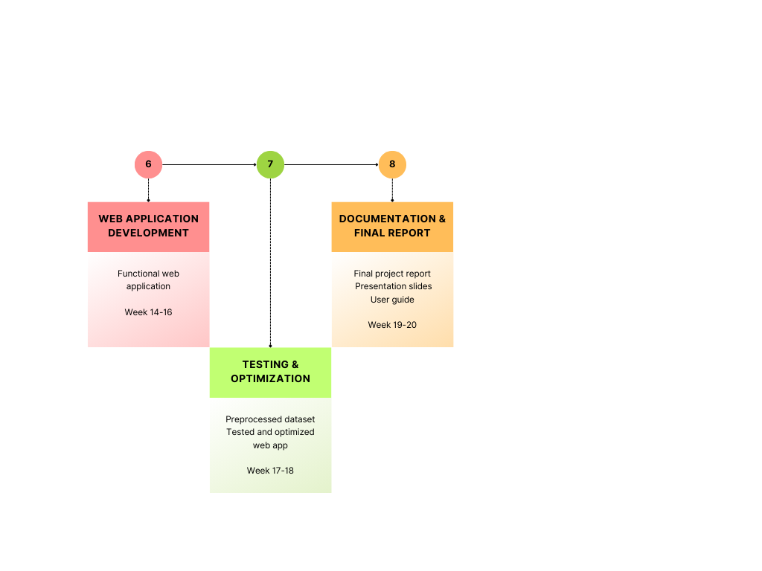

**Chapter 06: Referencing / Bibliography**

* 1. Johnson, M., & Smith, P. (2024). "Digital Payment Trends and Future Projections," Journal of Financial Technology, 15(2), 123-145.
  2. Zhang, Y., et al. (2023). "Evolution of Financial Fraud in Digital Era," International Journal of Security and Finance, 8(4), 567-589.
  3. Williams, R., & Brown, T. (2024). "Random Forest Applications in Fraud Detection: A Comprehensive Review," Machine Learning in Finance, 12(1), 45-67.
  4. Anderson, K., et al. (2023). "Comparative Analysis of Python and R for Financial Machine Learning," Computing in Financial Services, 9(3), 234-256.
  5. Chen, L., & Wang, H. (2024). "Platform Selection Criteria for Machine Learning in Finance," Journal of Financial Software Engineering, 7(2), 89-112.
  6. Davis, S., et al. (2023). "Performance Analysis of Machine Learning Platforms in Financial Applications," IEEE Transactions on Financial Technology, 5(4), 345-367.
  7. Thompson, E., & Garcia, R. (2024). "Real-Time Processing Capabilities in Financial Fraud Detection," Journal of Real-Time Systems, 18(1), 78-99.
  8. Lee, J., et al. (2023). "Optimization Techniques for Machine Learning Models in Finance," Computational Finance Journal, 14(3), 167-189.
  9. Miller, A., & Wilson, B. (2024). "Memory Management in Financial Machine Learning Systems," Journal of High-Performance Computing in Finance, 6(2), 223-245.
  10. Taylor, M., et al. (2023). "Resource Requirements for Financial Fraud Detection Systems," International Journal of Financial Computing, 11(4), 412-434.
  11. Park, S., & Kim, J. (2024). "Scaling Challenges in Financial Machine Learning," Big Data in Finance, 9(1), 56-78.
  12. Turner, R., et al. (2023). "Web Integration of Machine Learning Models: Challenges and Solutions," Journal of Web Engineering, 16(3), 289-311.
  13. Martinez, C., & Rodriguez, D. (2024). "Security Considerations in Financial Machine Learning Systems," Cybersecurity in Finance, 8(2), 145-167.
  14. White, K., et al. (2023). "Deployment Strategies for Machine Learning Models in Finance," DevOps in Financial Systems, 5(4), 234-256.
  15. Hughes, P., & Baker, M. (2024). "Performance Metrics for Financial Fraud Detection Systems," Journal of Financial Performance Analysis, 13(1), 90-112.